Step 1:
Save the attached Doc (ScreenShot) in your Local.

Step 2:
Open IE and Right Click on the Tool bar and make sure “Favourites Bar” is enabled.
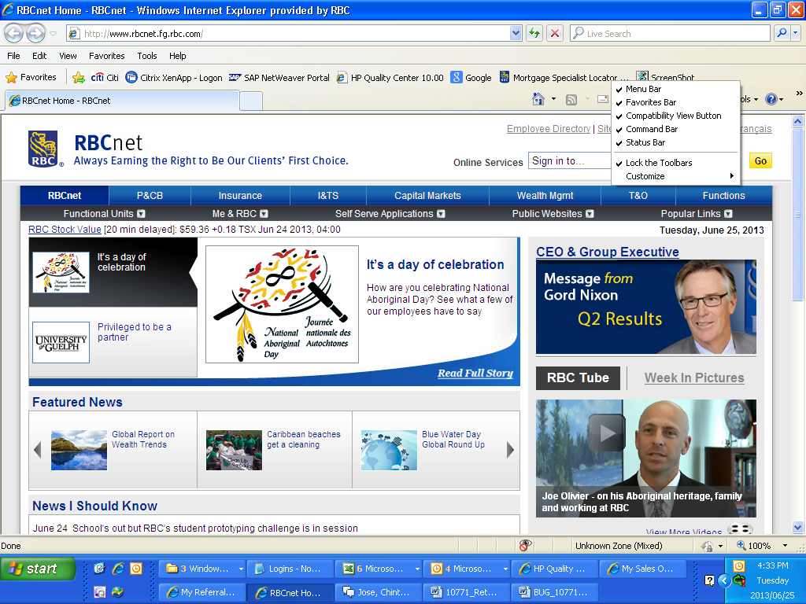
Step 3:
Drag the “ScreenShot” Doc and fix it in the Tool bar.

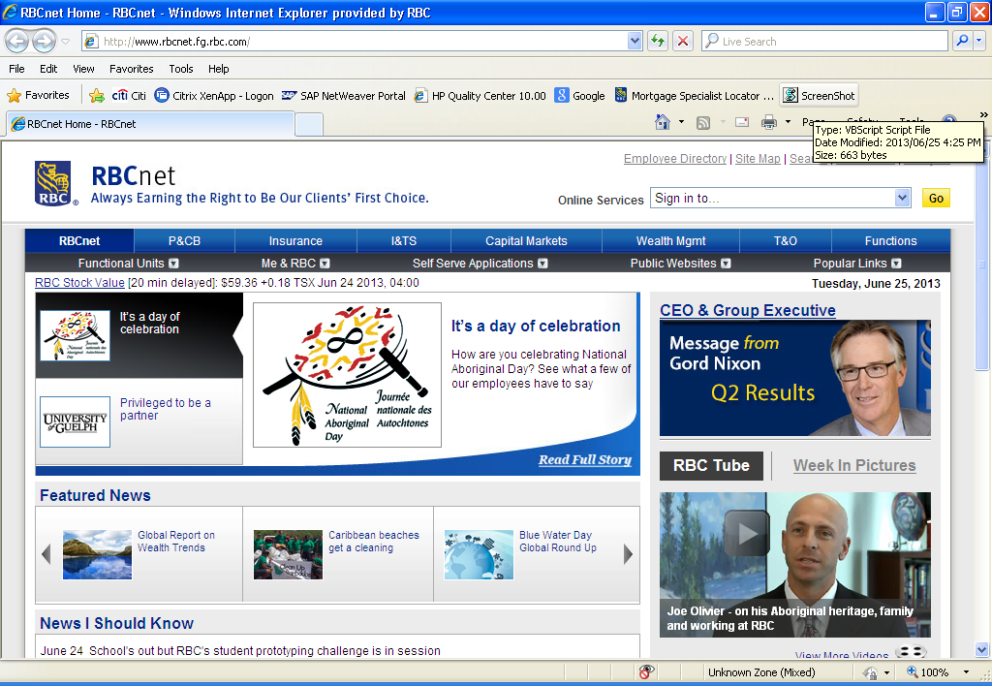
Step 4:
Create any Folder in your Local.
For E.g. Screen Print
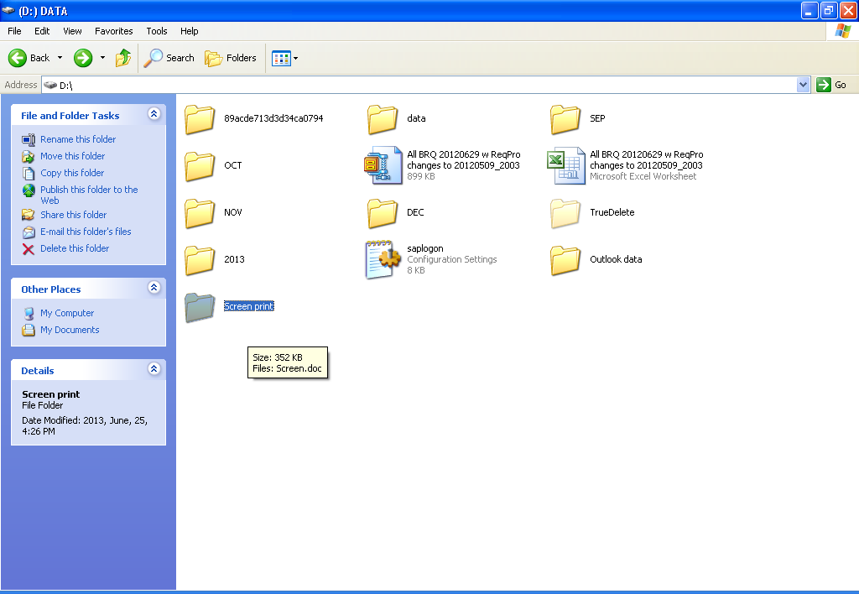
Step 5:
Create a Word Doc in the Folder Screen Print
For e.g. Screen
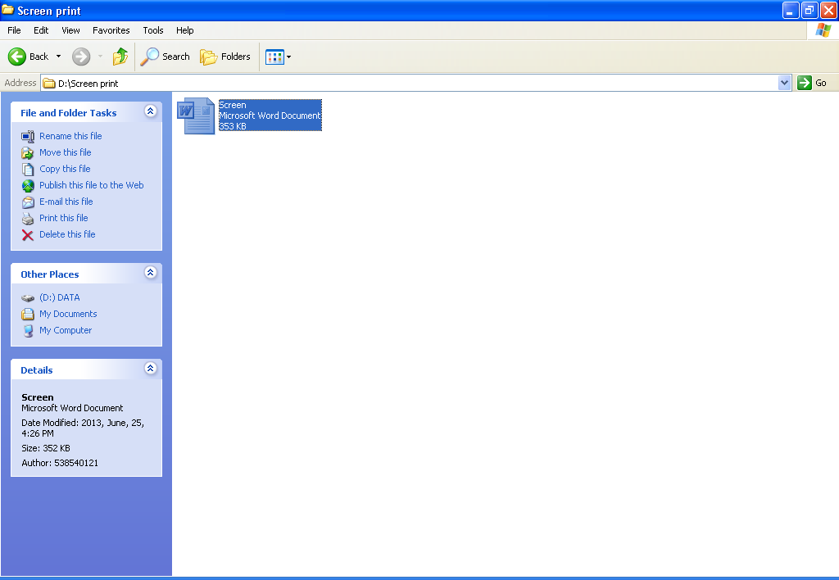

Step 6:
Now Copy the Path of your Word file location along with the name of the Document.
For e.g. “D:\Screen print\Screen.doc”

Step 7:
Right Click the File “ScreenShot” and Click on Edit to paste the location of your File and Save the File.
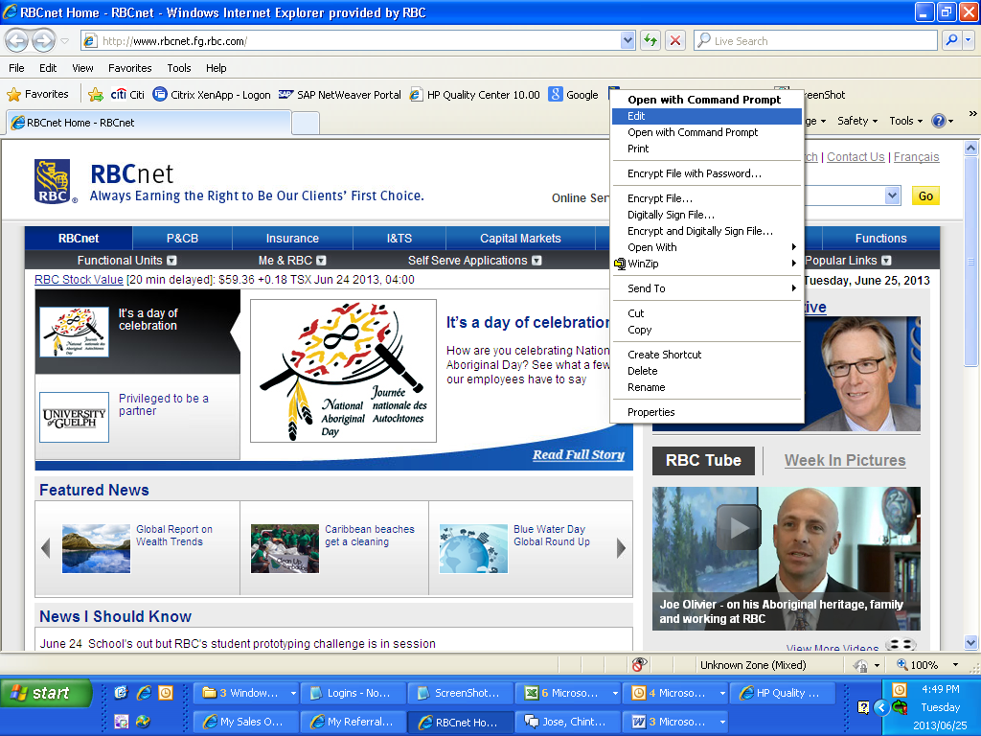

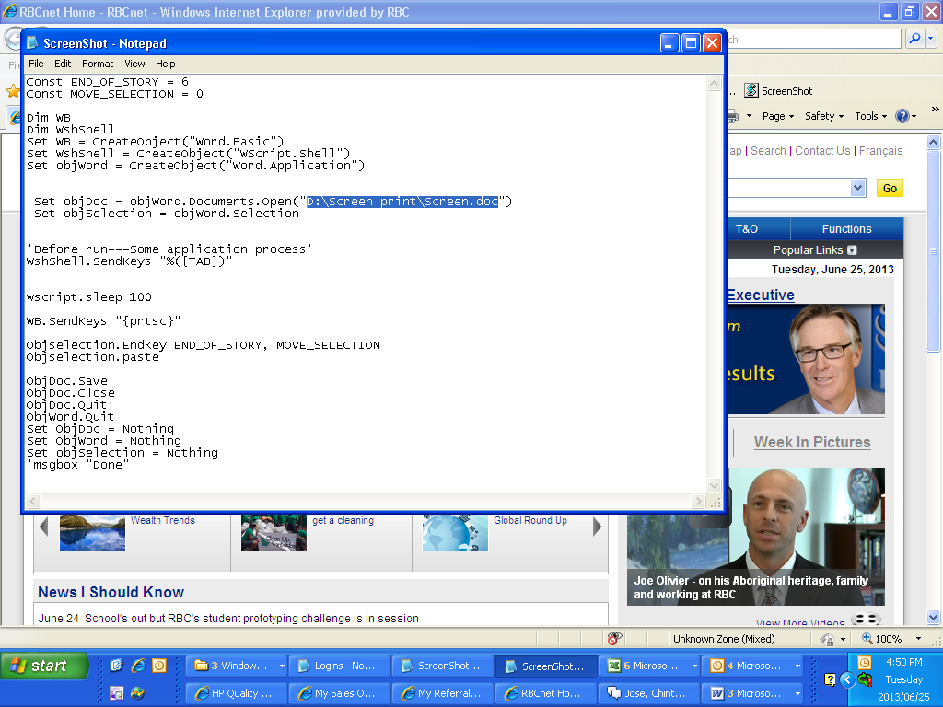

Step 8:
Now just open your application that you have to take the screen print and then Click the “ScreeShot” Doc
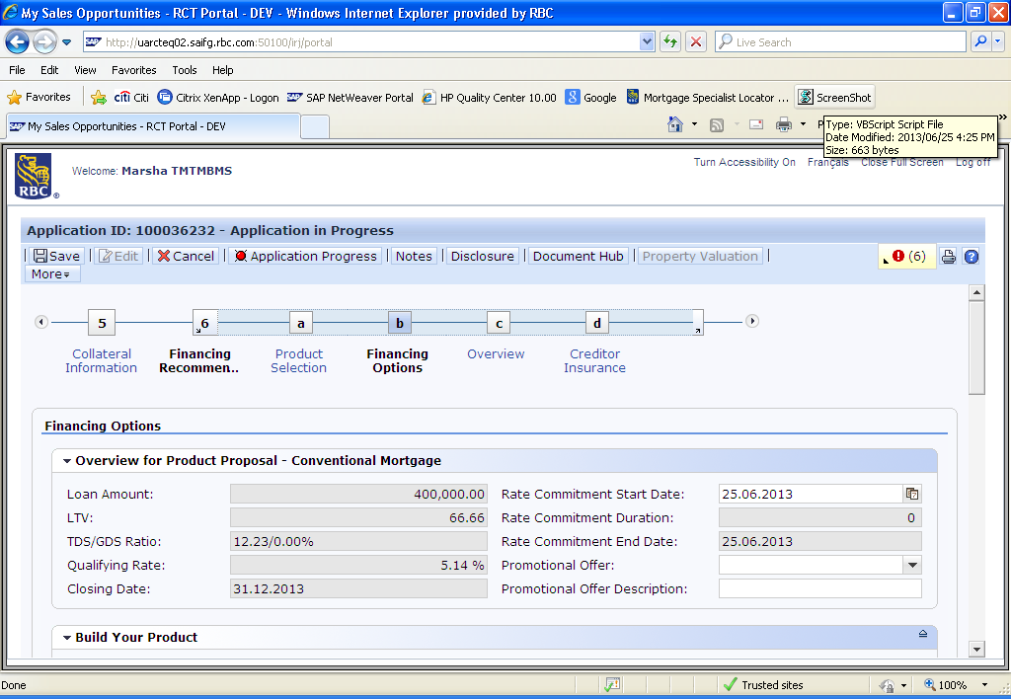

Step 9:
Check the newly created “Screen” document for your screen print.

